***Manipulating Styles with jQuery***

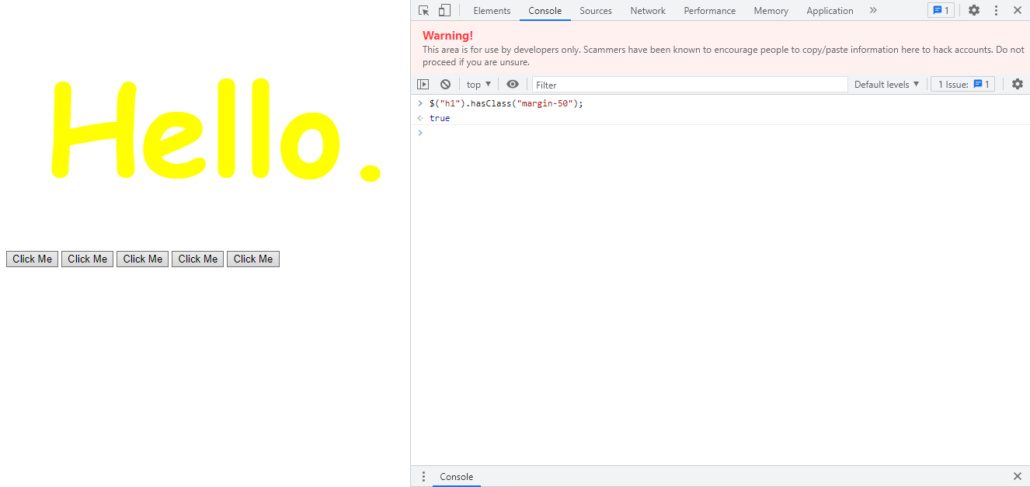

$("h1").hasClass("margin-50");

***Code:***

**Index1.html:**

<!DOCTYPE html>

<html lang="en" dir="ltr">

<head>

<meta charset="utf-8">

<title>jQuery</title>

<link rel="stylesheet" href="styles1.css">

</head>

<body>

<h1>Hello.</h1>

<button>Click Me</button>

<button>Click Me</button>

<button>Click Me</button>

<button>Click Me</button>

<button>Click Me</button>

<script src="https://ajax.googleapis.com/ajax/libs/jquery/3.6.0/jquery.min.js"></script> <!--Paste it above below tag-->

<script src="index1.js" charset="utf-8"></script>

</body>

</html>

**Index1.js:**

$('h1').css('color'); //this shows the current value of h1 element

console.log($('h1').css('color'));

If this property has single value then you are getting the value and if this property has 2 values then you are setting the value.

//$('h1').css('color','green');

//console.log($('h1').css('color'));

//console.log($('h1').css('font-size'));

//$('h1').css('font-size','5rem'); instead this add big-title class

//$('h1').addClass('big-title');

//Remove big-title class

//$("h1").removeClass("big-title");

$('h1').addClass('big-title margin-50'); //Two classes

$("button");

//Explore above code by runing one by one

**Styles1.css:**

.big-title{

font-size: 10rem;

font-family: cursive;

color: yellow;

}

.margin-50{

margin: 50px;

}